SPONSORSHIP OPPORTUNITIES

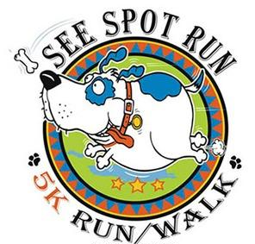

November 6th, 2021
EARLEWOOD PARK

FOR THE PREVENTION OF CRUELTY TO ANIMALS

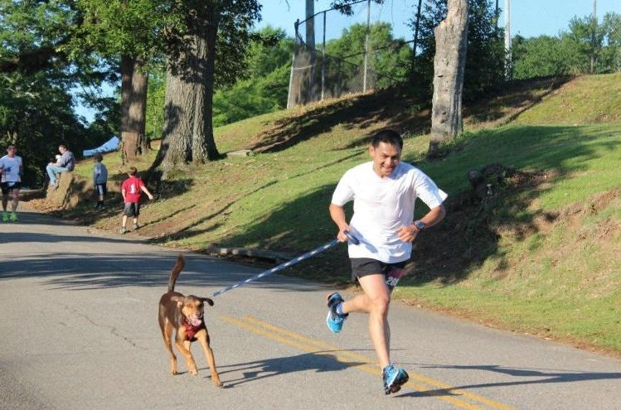
For more information, visit
HUMANESC.ORG/see-spot-run-5k/
facebook.com/humanecolumbiasc
@HSPCAColumbiaSC

@humanesocietysc

PRESENTING SPONSOR: $5,000

Exclusive designation as Presenting Sponsor for See Spot Run: (“Humane Society’s See Spot Run presented by "your organization’s name and logo”)
Logo on event day signage at Start and Finish Lines
Name and logo on event shirts
Name, logo and recognition in the Humane Society’s weekly email to more than 4,500 subscribers
Special thanks with logo and recognition on Humane Society’s web page, Facebook page, Instagram and Twitter feed.
Logo on runner awards
Complimentary race entry for 8 participants
Complimentary vendor booth
Logo or name on promotional items

PLATINUM SPONSOR: $2,500
Logo on event day signage
Name and logo on event shirts
Name, logo and recognition in the Humane Society’s weekly email to more than 4,500 subscribers
Special thanks with logo and recognition on Humane Society’s web page, Facebook page, Instagram and Twitter feed
Complimentary race entry for 4 participants
Complimentary vendor booth
Logo or name on promotional items

GOLD SPONSOR: $1,000
Logo on event day signage
Name and logo on event shirts
Name, logo and recognition in the Humane Society’s weekly email to more than 4,500 subscribers
Special thanks with logo and recognition on Humane Society’s web page, Facebook page, Instagram and Twitter feed
Complimentary race entry for 2 participants
Complimentary vendor booth

START/FINISH LINE SPONSOR: $750
Name, logo and recognition in the Humane Society’s weekly email to more than 4,500 subscribers
Dedicated space for company signage and/or company vehicle at Start/Finish line
Special thanks with logo and recognition on Humane Society’s web page, Facebook page, Instagram and Twitter feed

SILVER SPONSOR: $500
Name, logo and recognition in the Humane Society’s weekly email to more than 4,500 subscribers
Special thanks with logo and recognition on Humane Society’s web page, Facebook page, Instagram and Twitter feed.

WATER STOP SPONSOR: $250
Reserved space for signage and/or vehicle at sponsored water stop
Name, logo and recognition in the Humane Society’s weekly email to more than 4,500 subscribers
Special thanks with logo and recognition on Humane Society’s web page, Facebook page, Instagram and Twitter feed.

SPONSORSHIP APPLICATION
November 6th, 2021
*** Applications need to be submitted by October 1st, 2021****

Sponsorship Level (Check One)

__Presenting ($5,000) __Platinum ($2,500) __Gold ($1,000)
__Start/Finish ($750) __Silver ($500) __Water Stop ($250)

Please print the following information and mail it along with your payment to:

The Humane Society, Attn: See Spot Run, 405 Greenlawn Dr, Columbia, SC 29209

Sponsor Name:
Contact Name:
Address:
Email:
Phone:
Fax:
Preferred Payment: | ___Check* ___Credit Card  *Please make checks payable to The Humane Society
Credit Card #:
 | Expiration Date: CV Code:
Address:
Email:
Phone:

For questions or for more information, please contact Dawn Wilkinson at 803.783.1267 or dawn.wilkinson@humanesc.org

